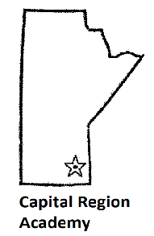 | FALL FORUM 2024 REGISTRATION FORM  Saturday, October 5th, 2024  Canad Inns – Club Regent  Ambassador event rooms
Please Print Clearly
Last Name | First Name |  | Phone Number
Email address | Place of Employment |  | Work Phone Number
I will attend evening reception: Yes ⃣ No ⃣
2024 Fees
Please indicate whether you are a MAMLS member and submit proof of membership
MAMLS Member: $75 ⃣ |  | Non MAMLS Member: $125 ⃣
Please indicate your payment option below:
⃣ Cash
⃣ Cheque – Payable to: Capital Region Academy
⃣ E-Transfer – send to rebizant.ff2024@gmail.com
Please note answer to security question: FallForum24
Send Registration Form & payment to:
Tara Brown or Karey Lachuta
Hematology Laboratory
Health Sciences Centre
MS559 – 820 Sherbrook Street
Winnipeg, Manitoba R3A 1R9

- Please include a photocopy of your 2024 MAMLS membership if applicable
  - Note: $75 fee will not be accepted without proof of 2024 MAMLS membership
- Confirmation of registration will be emailed. Please include your email address in the registration details. Please write legibly.
- Receipts for payment and CE Certificates will be available at the end of the last presentation.
- Enrollment is limited to 150 people
- Questions please contact: Marlene Rebizant marlenerebizant@gmail.com
- Registration Deadline: Tuesday, September 24, 2024
- Doors open at 8am October 5th, 2024 – first presentation at 08:30

Dietary Restrictions:

