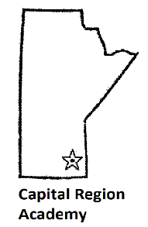 | SPRING FLING 2022 REGISTRATION FORM  Saturday, April 9, 2022  Canad Inns – Club Regent  Ambassador event rooms

Please Print!
Name: Place of Employment:
Email:
Phone #: Work phone #:
Attending evening reception? Yes No

2022 Fees
MAMLS Member: $65[membership proof required] | Non MAMLS Member: $110
Med Lab Science Graduates from 2020 & 2021: $30
Payment
Cash or Cheque
Payable to: Capital Region Academy
Send to:
Darrell Nazar or Pixie Gabriel
Hematology Laboratory
Health Sciences Centre
MS559 – 820 Sherbrook Street
Winnipeg, Manitoba R3A 1R9

- Please include a photocopy of your 2022 CSMLS/MAMLS card if applicable
  - Note: $65 fee will not be accepted without proof of membership
- At this time proof of double immunization will be required to attend
- Enrollment is limited to 150 people
- Confirmation of registration will be emailed. Please include your email address in the registration details
- Receipts for payment and CE Certificates will be available at the end of the last presentation on event day
- Any questions please contact Darrell or Pixie at 204-787-1584 dnazar@sharedhealthmb.ca or pgabriel@sharedhealthmb.ca
- Registration Deadline: Wednesday, March 30, 2022
- Doors open at 8am April 9, 2022 – first presentation at 08:30
Dietary Restrictions:

