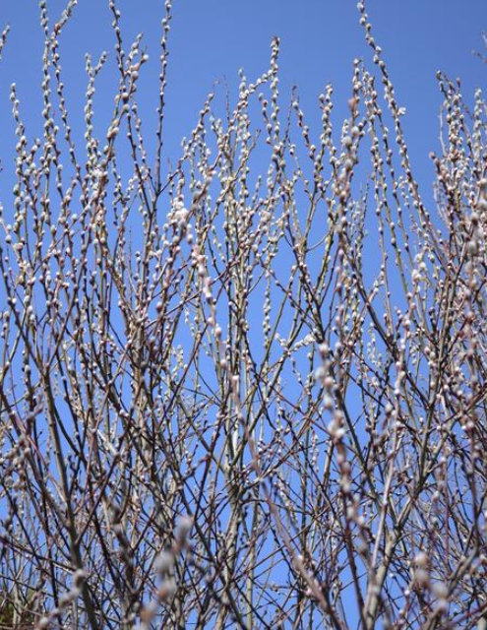

**Speakers**

Natalie Landry -Biochemistry

Divya Karsanji - Hematology

Qingdong Guan – Cellular Therapy

Mike Drebot - Pathology

John Embil – Infectious Diseases

Chris Hayes - Cardiology

Any questions please contact:

Darrell or Pixie at 204-787-1584 [dnazar@sharedhealthmb.ca](mailto:dnazar@sharedhealthmb.ca) or [pgabriel@sharedhealthmb.ca](mailto:pgabriel@sharedhealthmb.ca)

Marlene at 204-461-1136 [marlenerebizant@gmail.com](mailto:marlenerebizant@gmail.com)

**Capital Region Spring Fling**

**Saturday, April 9th, 2022**

**Canad Inns Club Regent**

**Ambassador Rooms**

**1425 Regent Ave W, Winnipeg**